**NAME:………………………………………………………………………..…STREAM…………………..**

**NCBC LOWER SECONDARY LEVEL EXAMINATIONS**

**PHYSICS**

**SENIOR TWO**

**END OF YEAR 2024**

**2 Hours 15 Minutes**

**INSTRUCTIONS TO LEARNERS** • Answer all questions.

* Show all you’re working.
* All answers should be written in the spaces provided.

# SECTION A

1. One evening, Nayiga kept juice in a tightly filled and corked glass bottle in a deep freezer. On opening the freezer, the following morning, Nayiga found the glass bottle broken with the juice frozen. As a physics learner, explain to

Nayiga what happened? (5 marks)

……………………………………………………………………………………………………

……………………………………………………………………………………………………

……………………………………………………………………………………………………

……………………………………………………………………………………………………

……………………………………………………………………………………………………

……………………………………………………………………………………………………

……………………………………………………………………………………………………

……………………………………………………………………………………………………

………………………………………………………………………………………………...…

1. A one-day old chicks are vulnerable to extreme temperature. Opio is rearing chicken on a commercial scale and he has bought 1000 one-day chicks.

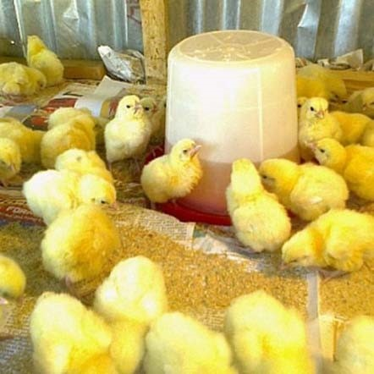

Suggest possible causes of extreme coldness and hotness in the chicken

house. (5 marks)

……………………………………………………………………………………………………

……………………………………………………………………………………………………

……………………………………………………………………………………………………

……………………………………………………………………………………………………

……………………………………………………………………………………………………

……………………………………………………………………………………………………

……………………………………………………………………………………………………

1. A barber wants to set up a salon in a room measuring length of 3m by 3m. He has a simple wooden chair, 3 large mirrors and one bulb.



Using the knowledge of shadows and reflection, advise the Baber on how to arrange a good salon using the only items he has. (5 marks)

……………………………………………………………………………………………………

……………………………………………………………………………………………………

……………………………………………………………………………………………………

……………………………………………………………………………………………………

……………………………………………………………………………………………………

……………………………………………………………………………………………………

……………………………………………………………………………………………………

1. After completing ordinary level, you and a classmate from your village have agreed to join a technical institution after which you will set up a workshop. On completion of your technical course you are offered space measuring 6mx 10m. using your knowledge of physics and laboratory, suggest activities for the workshop that are relevant to your community. (5 marks)

……………………………………………………………………………………………………

……………………………………………………………………………………………………

……………………………………………………………………………………………………

……………………………………………………………………………………………………

……………………………………………………………………………………………………

……………………………………………………………………………………………………

……………………………………………………………………………………………………

…………………………………………………………………………………………………… ……………………………………………………………………………………………………

1. Mr. owiny and Mr.ochen had an argument over the width of the path thatseparates their land. Mr. owiny claimed that the path is 12 feet wide. However, Mr.Ochen claimed it was 10 feet. When the chairman intervened, he measured the path with a foot rule and found out that it was 8 feet, after that the three were in disagreement.
2. Why did Mr. Owiny and Mr.Ochen fail to agree on the width of their path?

(02 mark)

……………………………………………………………………………………………………………

……………………………………………………………………………………………………………

……………………………………………………………………………………………………...........

.................................................................................................................................

1. Why do you think the chairman got a different measurement? (01 mark)

……………………………………………………………………………………………………………

……………………………………………………………………………………………………………

…………………...

1. As a physics learner, how would you solve the disagreement? (02 marks)

……………………………………………………………………………………………………………

……………………………………………………………………………………………………………

……………………………………………………………………………………………………………

6.A book of 32 pages is bound with sheets of paper each of thickness 0.20mm and two covers each of thickness 0.50mm.What is the thickness of the book in.

(05 marks) i) mm

……………………………………………………………………………………………………………

……………………………………………………………………………………………………………

……………………………………………………………………………………………………………

…………………………………………………………………………………………………………… …………………………………………………………………………………………………………… ii) m

……………………………………………………………………………………………………………

……………………………………………………………………………………………………………

……………………………………………………………………………………………………………

……………………………………………………………………………………………………………

……………………………………………………………………………………………………………

7) Mrs. Joan prepared tea for her sick daughter. She dipped a tea bag in hot water and the color of water changed instantly.

1. By what process did the color of water change? (02 mark)

……………………………………………………………………………………………………………

…………………………………………………………………………………………………………… ………………………………………………………………………………………………………..….

1. Suggest a statement that summarizes the meaning of diffusion. (03 marks)

……………………………………………………………………………..……………………………

……………………………………………………………………………………………………………

……………………………………………………………………………………………………………

……………………………………………………………………………………………………………. 8) Mr. Alex and Mr. James applied forces of 16N and 25N on a table respectively.

Find the resultant force if

1. They both push the table. (02 marks)……………………………………………………………………………………………………………

……………………………………………………………………………………………………………

……………………………………..…………………………………………………………………… ……………………………………………………………………………………………………………

1. Mr. Alex pushes and Mr. James pulls the table. (03 marks)

……………………………………………………………………………………………………………

……………………………………………………………………………………………………………

……………………………………………………………………………………………………………

……………………………………………………………………………………………………………

# SECTION B

9.In your community some of the roads are maurram. During the rainy season Lorries and pickup trucks usually skid, slide or get stuck in the mud.

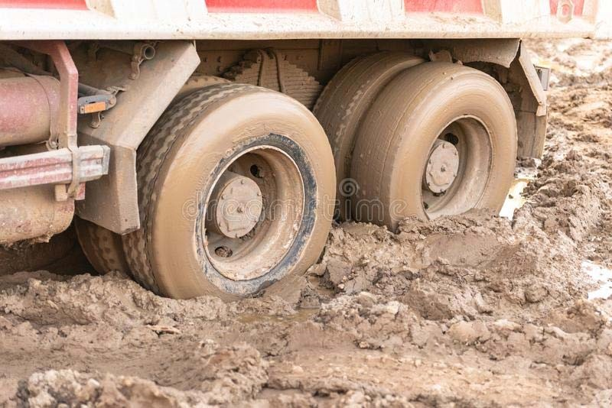

If you found a driver stuck in the mud (soft and slippery situation).

Tasks

1. Suggest possible ways to remove the truck from this position.
2. Advise the driver on how to avoid the above situation

# END SUCCESS BY MASTER ROBERT